Week -3 Homework-1

Name: Himavanth reddy putta Id:18759

Q8)

**Iterative:**

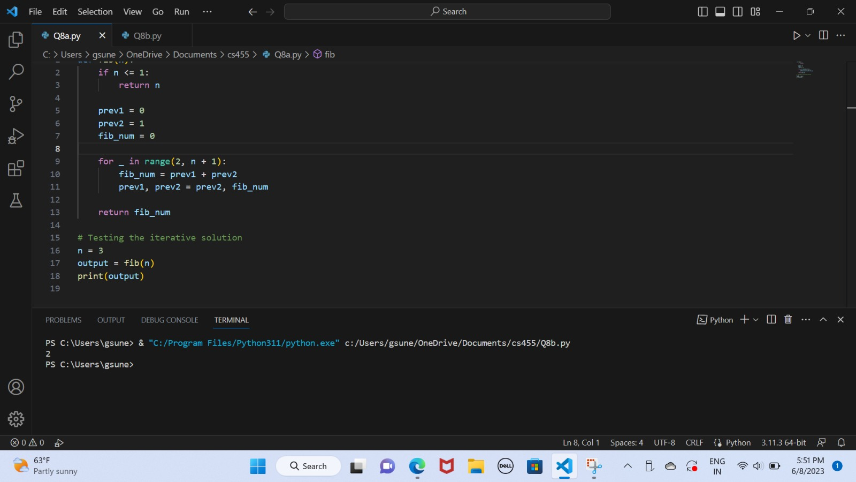

**Flowchart:**

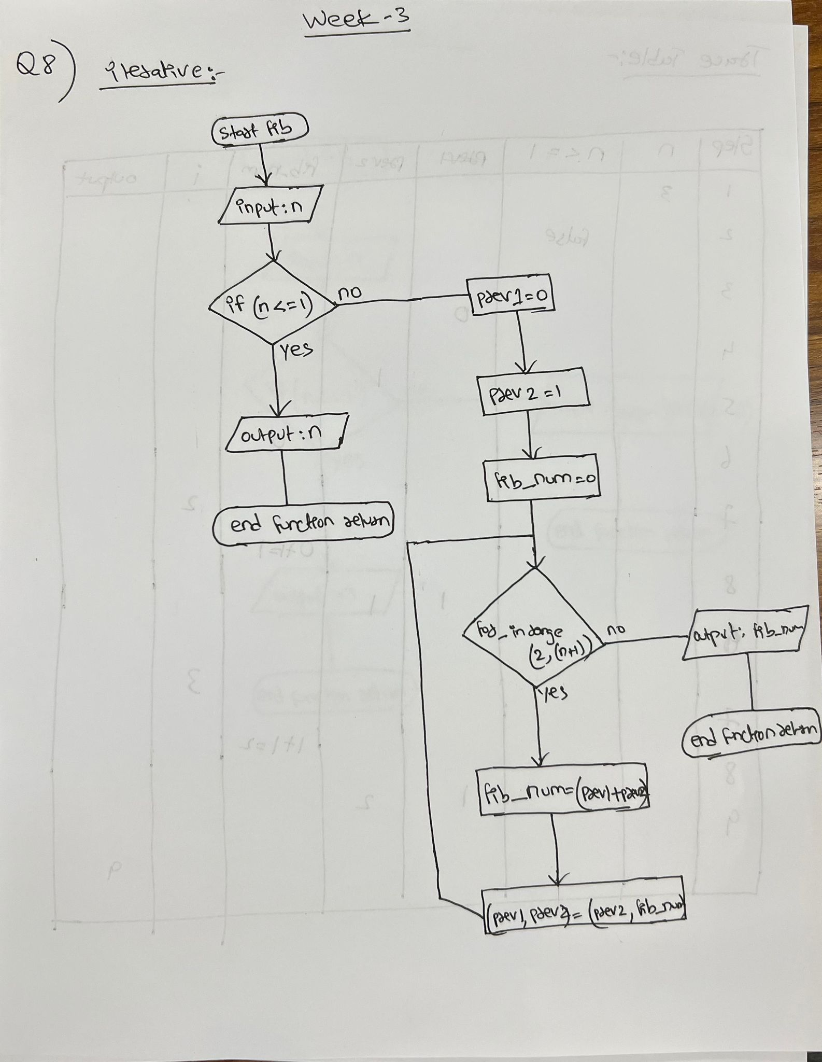

**Trace table:**

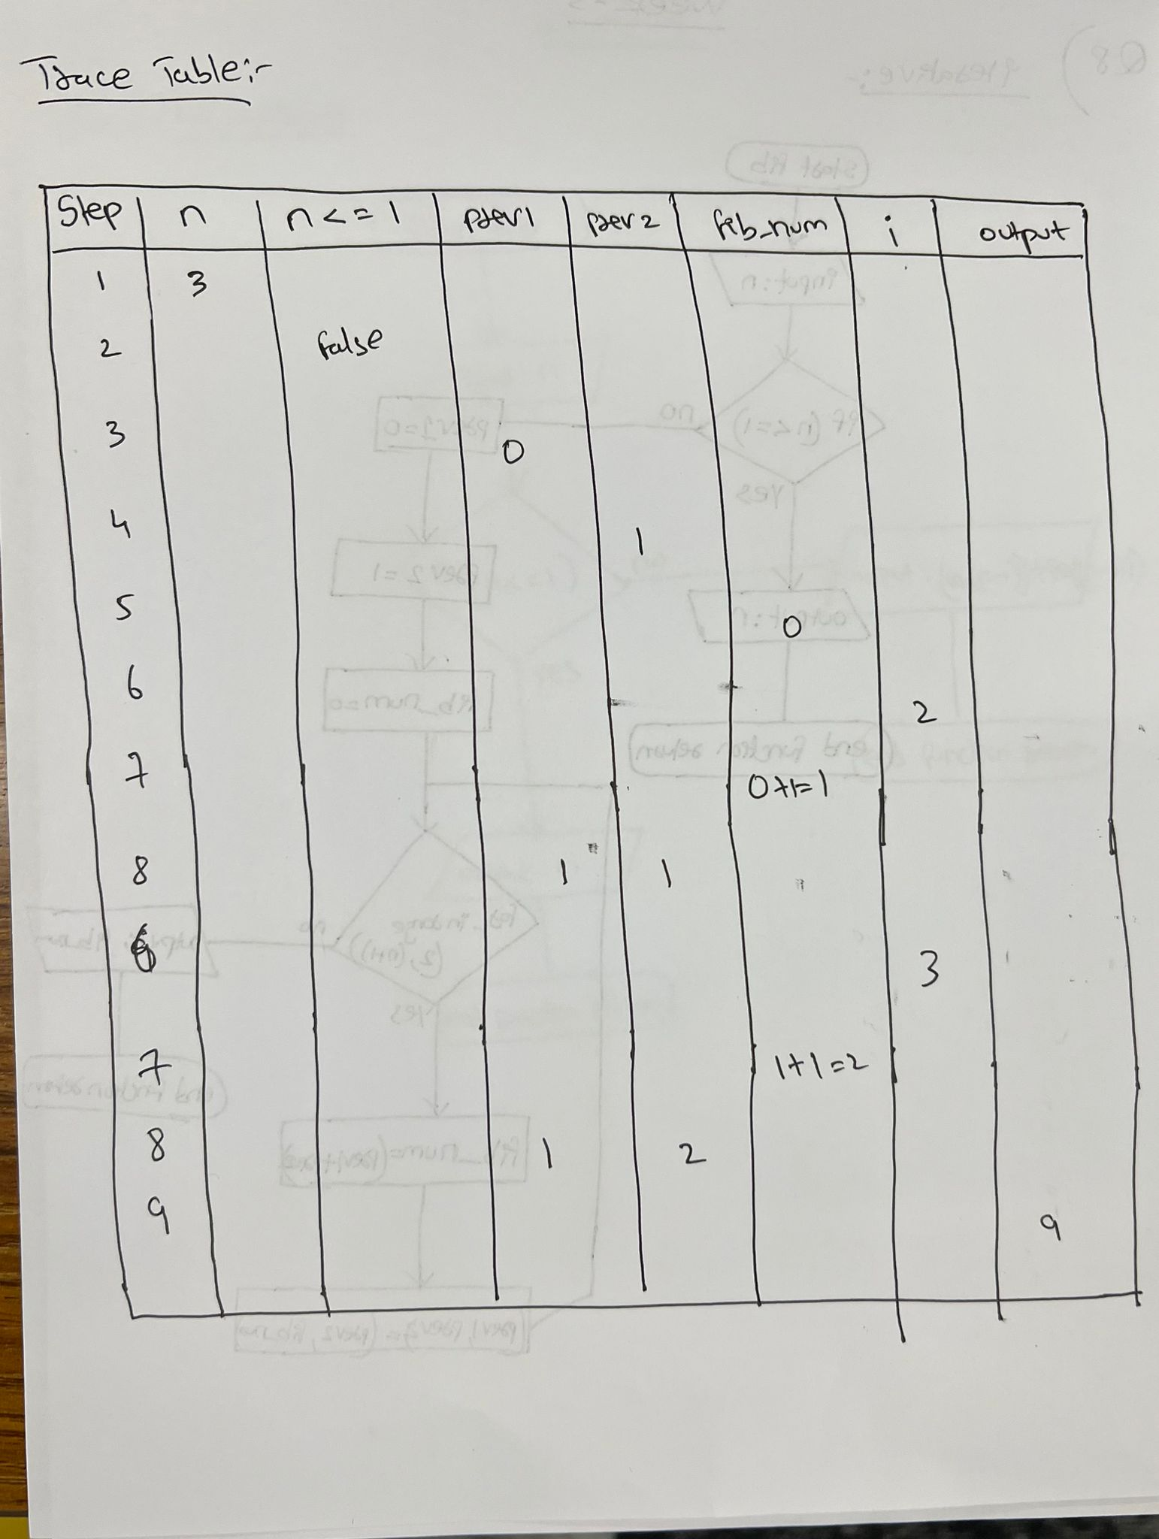

**Recursive:**

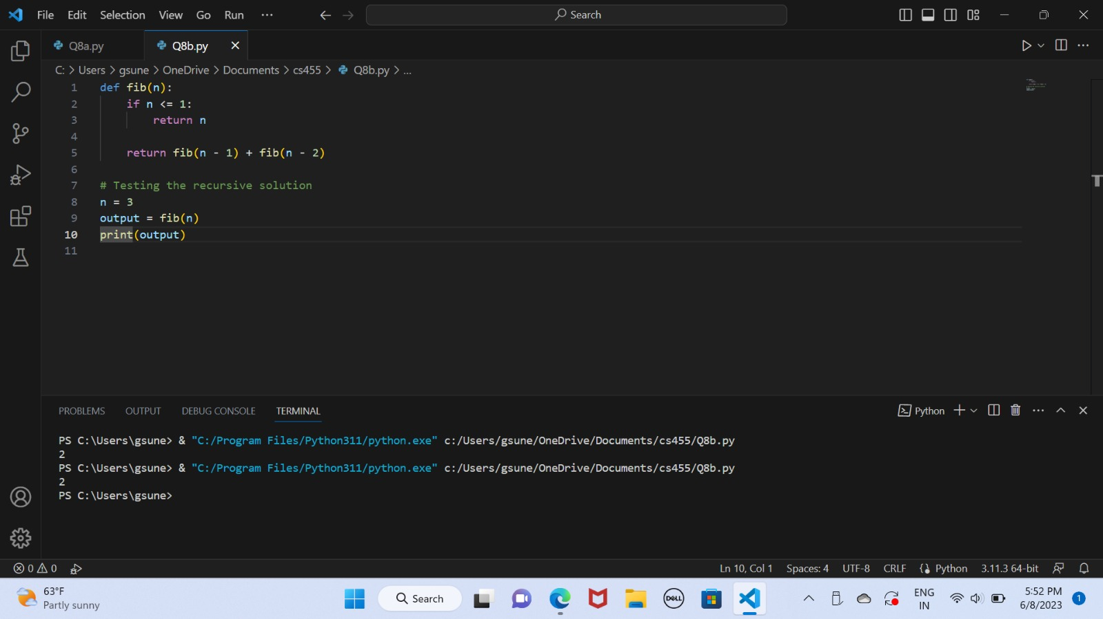

**Flowchart:**

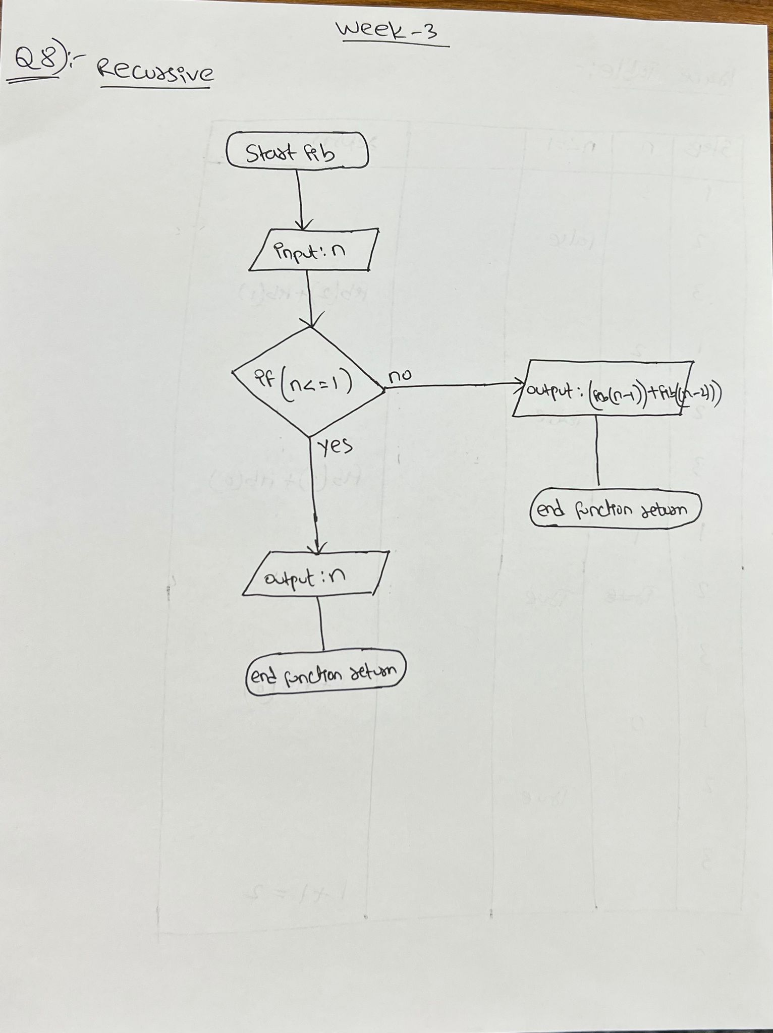

**Trace table:**

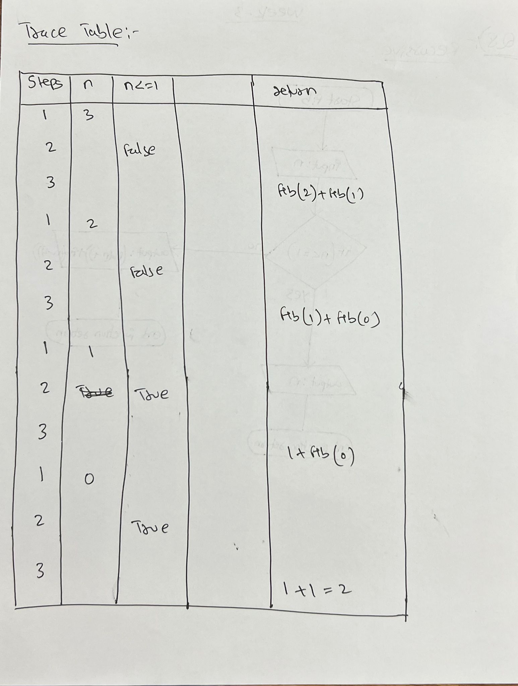

**Step 5 Code:**

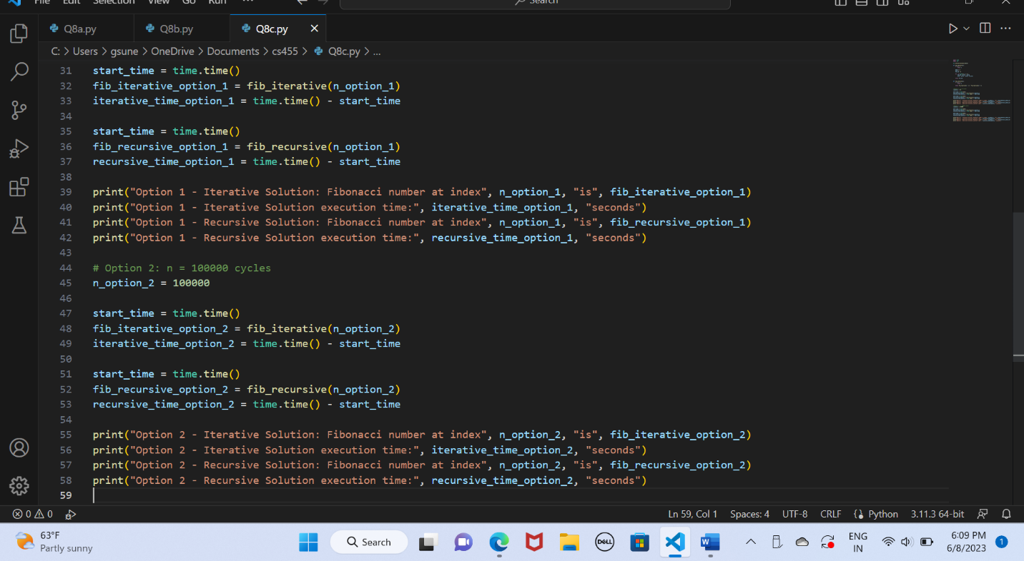

**Output:**

|  |  |  |
| --- | --- | --- |
| **Option** | **Iterative** | **Recursive** |
| **n = 20 cycles** | The program's [execution time](https://hc.labnet.sfbu.edu/~henry/npu/classes/algorithm/tutorialpoints_dsa/slide/measure_time.html) is **0.0 secs** | The program's [execution time](https://hc.labnet.sfbu.edu/~henry/npu/classes/algorithm/tutorialpoints_dsa/slide/measure_time.html) is **0.0** |
| **n = 100000 cycles** | The program's [execution time](https://hc.labnet.sfbu.edu/~henry/npu/classes/algorithm/tutorialpoints_dsa/slide/measure_time.html) is **program crashed** | The program has segmentation fault after running 1000 cyccles |
| **Big-O** | **O(n)** | **O(2n)** |